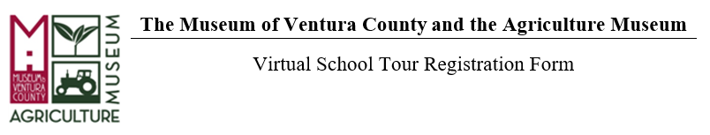
School: Click or tap here to enter text. Teacher Name(s):Click or tap here to enter text.
Address:Click or tap here to enter text. City/State/Zip: Click or tap here to enter text.
Phone Number: Click or tap here to enter text. Email: Click or tap here to enter text.

Class Info:
Grade Level: Click or tap here to enter text. Total # Students: Click or tap here to enter text.

Field Trip Program: (Please select only one; a new form is required for each virtual field trip.)
☐ Ag Museum Virtual Zoom Tour: “From the Land to My Hand” (Grade K-2); free
☐ Chumash Virtual Zoom Tour: “In the Spirit of Our Ancestors” (Grade 3-5); free
*Zoom tours can accommodate up to 90 students, and are available for a class, or a section of classes from the same school. These tours include the video/audio function and time for questions and answers.

See tour availability here: MVC Virtual Tour Calendar 2021

Date Request: (Please select 3 in order of preference)
1st Choice | 2nd Choice | 3rd Choice
Click or tap here to enter text. | Click or tap here to enter text. | Click or tap here to enter text.

Questions can be directed to the Education Department at (805) 525-3100 x104 or email us at: education@venturamuseum.org

Museum of Ventura County  100 E. Main Street  Ventura, CA 93001  (805) 653-0323 | Agriculture Museum  926 Railroad Avenue  Santa Paula, CA 93060  (805) 525-3100

