Agriculture Museum of Santa Paula
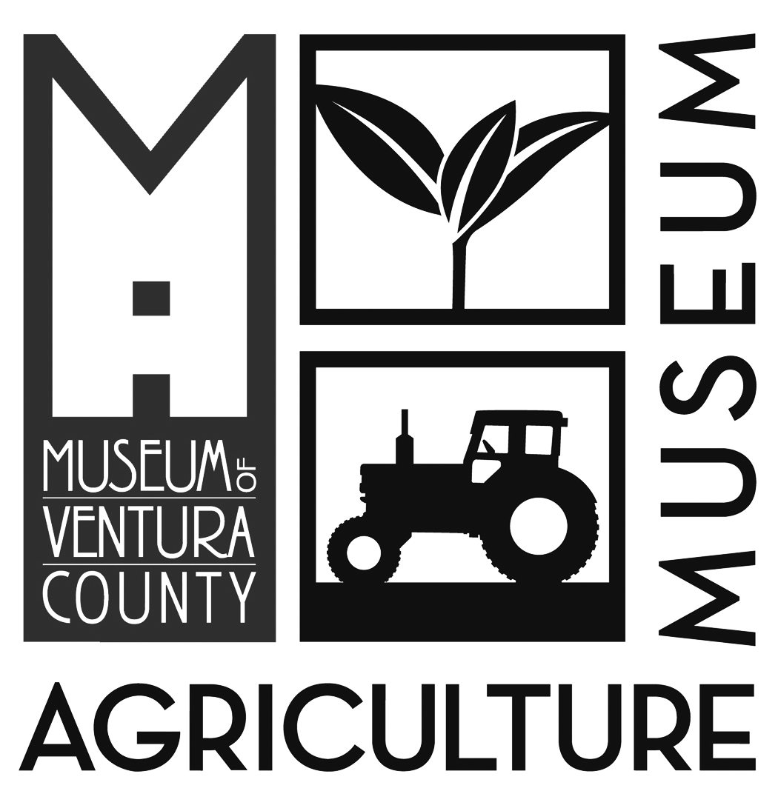
926 Railroad Ave.
Santa Paula, CA 93060

School Tour Registration Form

School:__________________________________________ Teacher Name(s):_________________________________________________

Address:____________________________________________ City/State/Zip:_________________________________________________

Phone Number: ___________________________________________ Email:____________________________________________________

Class Info:
Grade Level:______________ Total # Students (30 max):_____________________________________

Adult Chaperones (1 adult/12 students minimum):_________________

Field Trip Program:

______ Agriculture Museum Tour! (Grade 2) $5/student, adults free

______ Self-Guided Educational Tour $1/student, adults free

Agriculture Museum Guided Tours run 90 minutes, Tuesday, Wednesday, Thursday, 9:30am - 11am

Title 1 School:
Yes_______ No_______
*Title 1 schools have all admission fees waived and are eligible for bus transportation grants.
Title 1 Bus Grant: I am applying for Bus Grant Reimbursement (see page 2) Yes_______ No_______

Date Request: (Please select 3 in order of preference)
1st Choice | 2nd Choice | 3rd Choice

Special Accommodations request: Accessibility needs, food/insect allergies, etc. Yes_______ No_______

(If yes, please describe):_______________________________________________________________________________________________

Questions can be directed to the Education Department at (805) 525-3100 x103 or education@venturamuseum.org

Let’s get your class to the Museum!
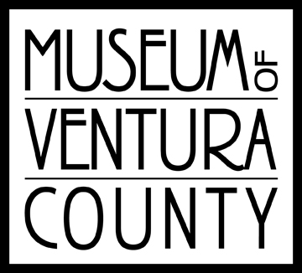
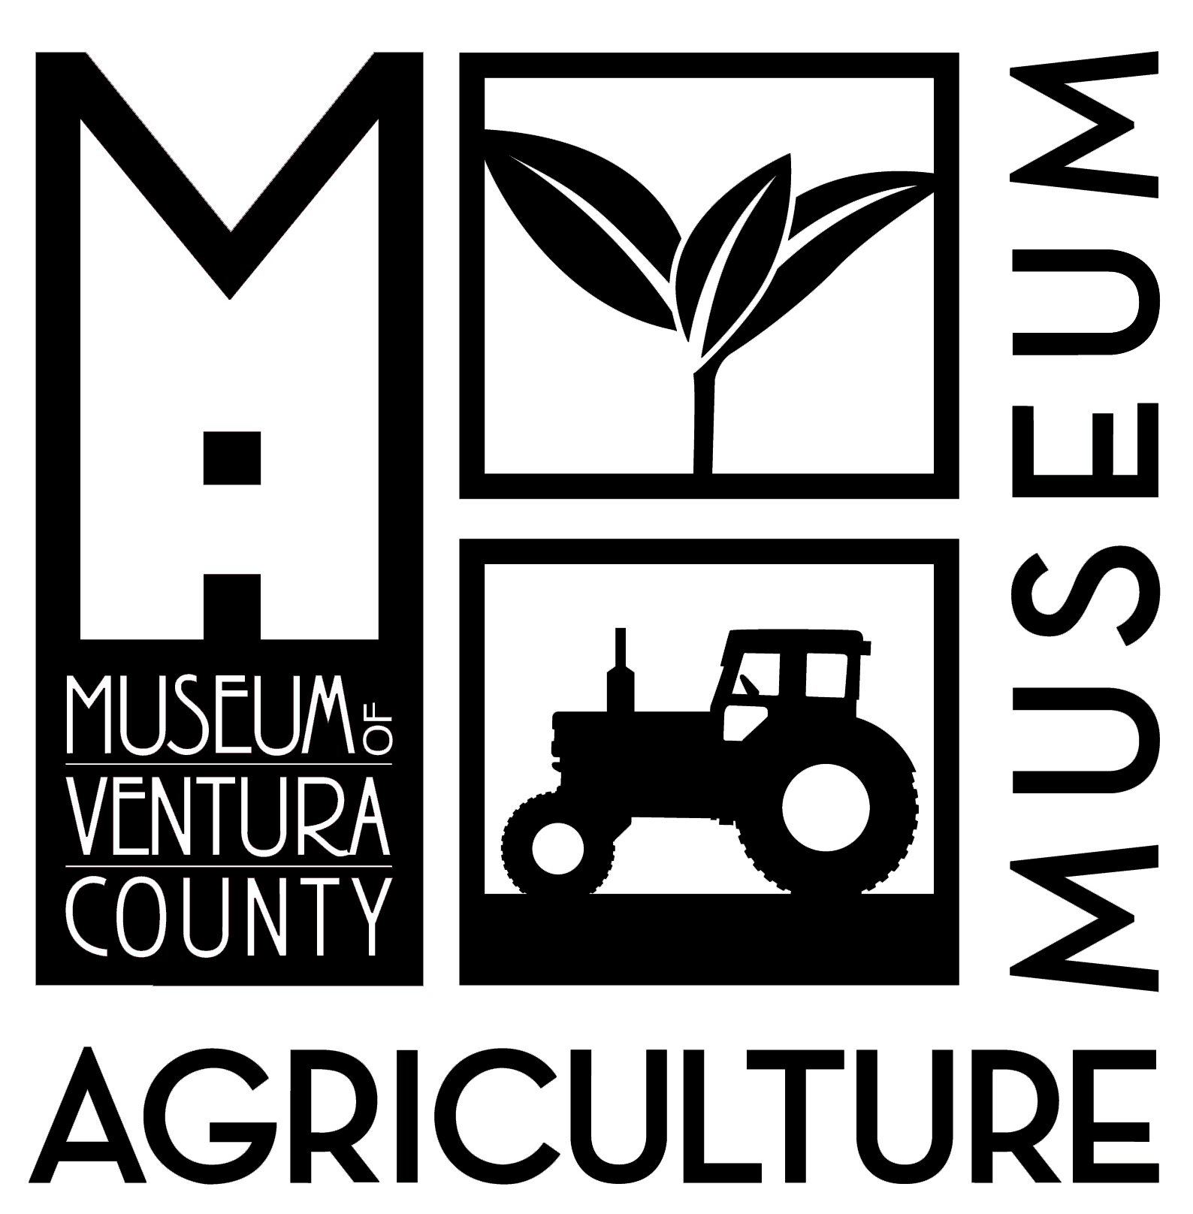

Title 1* School Bus Grant Reimbursement Request Form
- Fill out this form and include with your registration request.
- We will confirm receipt of the transportation fee reimbursement request.
- The reimbursement covers up to $250 per day in bus costs.
- Within 60 days AFTER your school tour, please submit a copy of your bus fee invoice to us at:
Email:  education@venturamuseum.org | By mail:  Museum of Ventura County  Attn: Education Department  100 E. Main St  Ventura CA, 93001

Amount of grant requested (Maximum $250):______________
Is this your first time you’ve taken your students to the Museum of Ventura County? | Yes_____ No_____
Would you have been able to attend the Museum without this bus grant? | Yes_____ No_____

Funding for this reimbursement program is limited, reimbursement requests will be processed on a first-come first-serve basis while this grant is available.

*Title 1 is a federal program that supplies school districts with additional funding and resources to help improve instruction in high-poverty schools; thereby, insuring that all children have a fair, equal, and significant opportunity to obtain a high quality education and reach (at minimum) "PROFICIENT" status on challenging state academic standards and assessments. Title 1-Part A is the largest single program in the "No Child Left Behind Act of 2001 (NCLB)."

