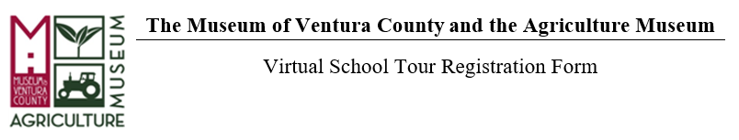
School: Click or tap here to enter text. Teacher Name(s):Click or tap here to enter text.
Address:Click or tap here to enter text. City/State/Zip: Click or tap here to enter text.
Phone Number: Click or tap here to enter text. Email: Click or tap here to enter text.

Class Info:
Grade Level: Click or tap here to enter text. Total # Students: Click or tap here to enter text.

Field Trip Program: (Please select only one; a new form is required for each virtual field trip.)
☐ Ag Museum Virtual Zoom Tour: “From the Land to My Hand” (Grade K-2); free
☐ Ag Museum Virtual Monthly WEBINAR Tour: “From the Land to My Hand” (Grade K-2); free
☐ Chumash Virtual Zoom Tour: “In the Spirit of Our Ancestors” (Grade 3-5); free
*Zoom tours can accommodate up to 90 students, and are available for a class, or a section of classes from the same school. These tours include the video/audio function and time for questions and answers.
*Monthly Webinar tours can accommodate up to 500 students and feature multiple museum educators and are conducted with the “Webinar” function on zoom to ensure privacy of participants from different schools.

See tour availability here: MVC Virtual Tour Calendar 2021

Date Request: (Please select 3 in order of preference)
1st Choice | 2nd Choice | 3rd Choice
Click or tap here to enter text. | Click or tap here to enter text. | Click or tap here to enter text.

Questions can be directed to the Education Department at (805) 525-3100 x104 or email us at: education@venturamuseum.org

Museum of Ventura County  100 E. Main Street  Ventura, CA 93001  (805) 653-0323 | Agriculture Museum  926 Railroad Avenue  Santa Paula, CA 93060  (805) 525-3100

